Excel Automation Data Entry Pipeline

Build a data pipeline that takes data currently entered or stored in Excel, moves it through a proper structured pipeline, and produces clean reporting outputs in Power BI.

  - Excel / Form App
  - ↓
  - Raw Data / Landing
  - ↓
  - Bronze Layer
  - ↓
  - Silver Layer
  - ↓
  - Gold Layer
  - ↓
  - Power BI Dashboard
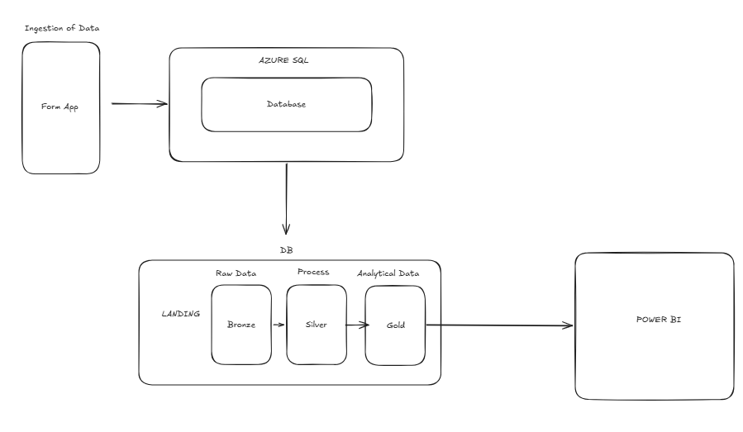
Contents
Business Context 3
Business Questions 3
Business Rules 3
Entities 4Pa
Relationships 4
Diagram ERD 6
Data Dictionary 7

Business Context
This project is about a company that currently manages operational work using Excel. The business needs a better way to capture, store, clean, and report its data.
A realistic business case:
Business: Property Maintenance / Mastic Services Company
The company receives jobs from clients, assigns workers, tracks job completion, records materials used, and reports performance.

Business Questions
How many jobs were completed?
Which workers completed the most jobs?
Which clients generate the most work?
How much revenue was made?
Which jobs are still pending?
How long does each job take?
What materials are being used?
Which areas/sites are busiest?

Business Rules
How does a job move from requested to completed for a mastic firm?

- A client requires a job
- The job is reviewed
- The job is booked
- A worker is assigned to the job
- Materials are prepared

- Materials are used
- Work is done
- Time of work is recorded
- Job is checked by client

- Job is marked as completed
- Invoice is sent to the client
- Payment is done by the client

Entities
Clients
Site
Job
Worker
Worker Assignment
Material
Material Usage
Work Record
Invoice
Payment

Relationships

Client <-> Site
One client can have many sites
One site belongs to one client

Site <-> Job
One site can have many jobs
One job belongs to one site

Job <-> Worker
One job can have many workers
One worker can be assigned to many jobs

Job <-> Material
One job can use many materials
One material can be used in many jobs

Job <-> Work Record
One job can have many records
One record belongs to one job

Client <-> Invoice
One client can have many invoices
One invoice belongs to one client

Invoice <-> Payment
One invoice can have many payments
One payment belongs to one invoice

Diagram ERD

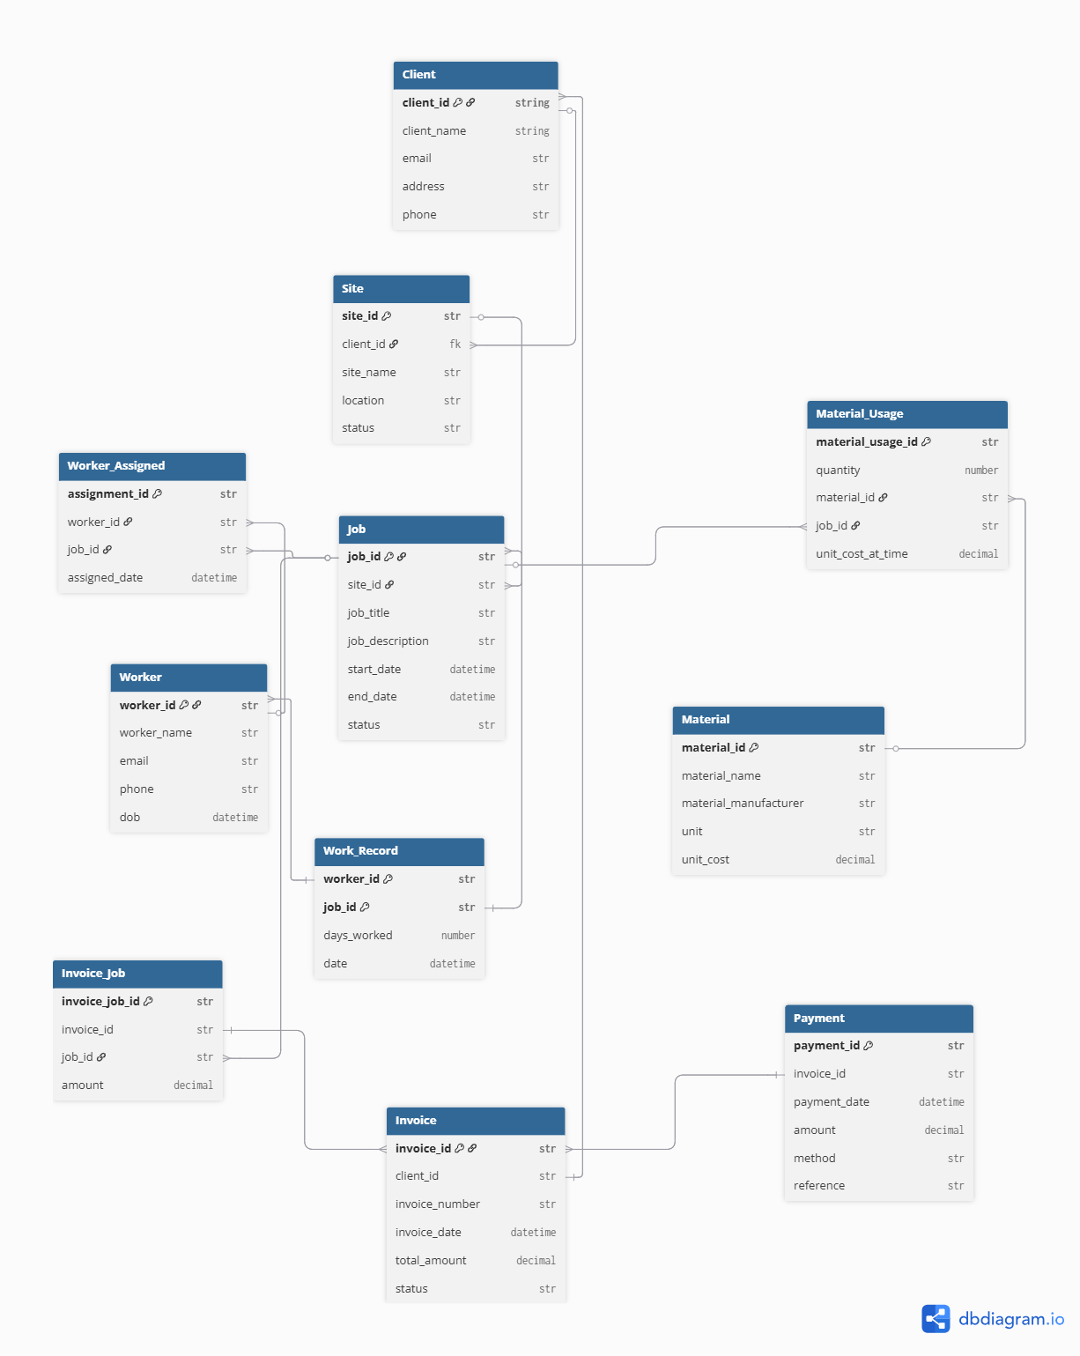

Data Dictionary

Table: Client
Purpose: Stores businesses or people requesting work
Main Fields: client_id, client_name, email, phone, address
Rules:
- One client can have many sites
- client_name is NOT NULL
- client_id is PK
- Email should be unique
- Phone and address are optional

Table: Site
Purpose: Store location where work is carried out for clients
Main Fields: site_id, client_id, site_name, location, status
Rules:
- One site can have many jobs
- One site belongs to one client
- site_name and locations are required
- site_id is PK
- client_id is FK referencing client

Table: Job
Purpose: Represents a unit of work request by client and performed by worker
Main Fields: job_id, site_id, job_title, job_description, start_date, end_date, status
Rules:
- One job can have many workers assigned to
- job_title and job_description are required
- job_id is PK
- site_id is FK referencing site
- One job belongs to one site
- One job can use many materials
- A job has status ( requested, booked, in progress, completed )
- Dates are optional, but recommended

Table: Worker
Purpose: Store workers information from the firm
Main Fields: worker_id, worker_name, phone, email, dob
Rules:
- worker_id is PK
- worker_name and phone are required
- one worker can be assigned to many jobs
- one worker can complete many work records

Table: Material
Purpose: To store material details and its cost
Main Fields: material_id, material_name, material_manufacturer, unit, unit_cost
Rules:
- material_id is PK
- All fields are required
- one material can be used in many jobs

Table: Worker Assignment
Purpose: It represents the worker assigned to a specific job
Main Fields: assignement_id, worker_id, job_id, assignement_date
Rules:
- assignment_id is PK
- worker_id is FK referencing Worker
- job_id is FK referencing Job
- All fields are required
- One worker assigned can have many assignments
- One assignment belongs to one worker
- One assignment belongs to one job
- One job can have many assignments

Table: Material Usage
Purpose: To track the usage of materials on jobs
Main Fields: material_usage_id, material_id, job_id, quantity, unit_cost_at_time
Rules:
- material_usage_id is PK
- material_id is FK referencing Material
- job_id is FK referencing Job
- All fields are required
- One material usage belongs to one material
- One material usage belongs to one job
- One material can appear in many material usage records
- One job can have many material usage records

Table: Work Record
Purpose: To track completion of works on days worked per job
Main Fields: work_record_id, worker_id, job_id, days_worked, date
Rules:
- work_record_id is PK
- worker_id and job_id are FK referencing Worker and Job respectively
- all fields are required
- one work record belongs to one job
- one work record belongs to one worker

Table: Invoice
Purpose: To store invoices on completed jobs
Main Fields: invoice_id, client_id, invoice_number, invoice_date, total_amount, status
Rules:
- invoice_id is PK
- client_id is FK referencing Client
- All fields are required
- An invoice has a status ( draft, sent, partially paid, paid, overdue, cancelled)
- One invoice can have many jobs
- One invoice belongs to one client
- One invoice can have many payments

Table: Invoice Job
Purpose: Links invoices to the jobs included in each invoice.
Main Fields: invoice_job_id, invoice_id, job_id, amount
Rules:
- invoice_job_id is PK.
- invoice_id is FK referencing Invoice.
- job_id is FK referencing Job.
- One invoice can include many jobs.
- One job can be linked to one invoice in the current model.

Table: Payment
Purpose: To record payments made on invoices
Main Fields: payment_id, invoice_id, payment_date, amount, method, reference
Rules:
- payment_id is PK
- invoice_id is FK referencing Invoice
- reference is the only optional field
- One payment belongs to one invoice

Form
https://forms.gle/uViiySNeMKCXgmE87

Logic

Column A: Timestamp
Column B: Client Name
Column C: Site Location
Column D: Job
Column E: Job Status
Column F: Start Date
Column G: End Date
Column H: Workers
Column I: Material 1
Column J: Quantity 1
Column K: Material 2
Column L: Quantity 2
Column M: Material 3
Column N: Quantity 3
Column O: Days Worked
Column P: Work Completed Date
Column Q: Job Price
Column R: Invoice Status
Column S: Invoice Amount

Mapping

FROM FORM
Client Name -> Client.client_name
Site Location -> Site.site_name
Job -> Job.job_title
Job Status -> Job.status
Start Date -> Job.start_date
End Date -> Job.end_date
Worker -> Worker.worker_name
Material 1 -> Material.material_name
Quantity 1 -> Material_Usage.quantity
Material 2 -> Material.material_name
Quantity 2 -> Material_Usage.quantity
Material 3 -> Material.material_name
Quantity 3 -> Material_Usage.quantity
Days Worked -> Work_Record.days_worked
Work Completed Date -> Work_Record.date
Job Price -> Invoice_Job.amount
Invoice Status -> Invoice.status
Invoice Amount -> Invoice.total_amount

DERIVED

Client
Client.client_name -> Client.client_id
Site
Site.client_id -> Client.client_id
Job
Job.job_id ->

